EXERCISE NUMBER:1 REGISTER NUMBER:RA2111026050026
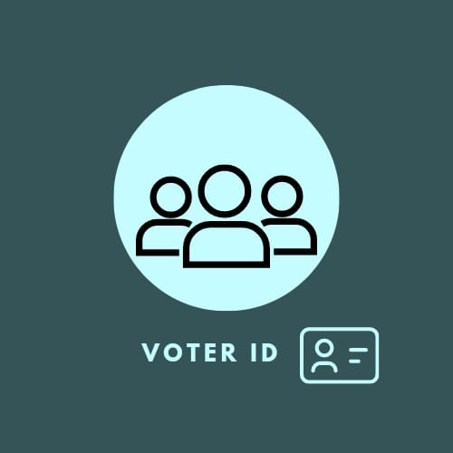

ONE PAGE BUSINESS CASE TEMPLATE

DATE | 24.01.2023
SUBMITTED BY | VISHNUPRIYAN S
TITLE / ROLE | Online Voter ID Card Application / Web Designer
THE PROJECT
- Democracy is an important matter in most modern societies.
- The problem of voting getting voter id card is still critical in terms of time taking.
- Online Voter ID Card Application System is an interface between the Applicant and the Authority responsible for the issue of voter id card
- If the entire process of the issue of the voter id card is done manually then it would take several months

THE HISTORY
- The manual system does not provide secured registration and profile management of the Applicants properly.
- In manual system, all details are taken in the form of documents, which can be misplaced anytime.
- Every individual had to stand in queue, which is more time consuming and involves more manpower
LIMITATIONS
- The Applicants require a computer to submit their information.
- Prior knowledge of computer skills is required
- Although the security is given high importance, there is always a chance of intrusion in the web world which requires
constant monitoring.
- The Applicant must be careful while submitting the information
APPROACH
Software Requirements &Hardware Requirements

- Windows 8 or later
- Intel Pentium 4 or later
- 4 GB RAM or higher
BENEFITS
- Security is provided.
- Less time consumption.
- Improves the efficiency.
- Reduces the complexities.
- Elimination of human error

DISCLAIMER

Any articles, templates, or information provided by Smartsheet on the website are for reference only. While we strive to keep the information up to date and correct, we make no representations or warranties of any kind, express or implied, about the completeness, accuracy, reliability, suitability, or availability with respect to the website or the information, articles, templates, or related graphics contained on the website. Any reliance you place on such information is therefore strictly at your own risk.

